5.1 & 5.2 Periodic Table Notes

History of the Periodic Table
A. Stanisloa Cannizzaro - 1860
1. presented a method to accurately measure relative atomic mass of the elements.

B. Dmitri Mendeleev – 1869
1. organized the elements according to increasing atomic mass

2. recognized regular repeating patterns in chemical and physical properties of the elements when they were organized

3. had to leave blank spaces in his table for undiscovered elements
a. predicted properties of these elements
b. when these elements were discovered their properties were very similar giving credence to the organization of the elements

4. Credited with the Periodic Law

C. Henry Moseley – 1911
1. reorganized the elements according to increasing nuclear charge
a. nuclear charge = atomic number
D. Periodic Law
- the chemical and physical properties of the elements are periodic functions of their atomic numbers.

The Periodic Table
A. Organization of the elements
1. Horizontal rows are known as periods
a. There are 7 periods

2. Vertical columns are known as groups or families
b. There are 18 groups
1. Group 1: Alkali metals
2. Group 2: Alkaline-Earth metals
3. Group 16: Chalcogen (Oxygen) Family
4. Group 17: Halogen Family
5. Group 18: Noble Gases
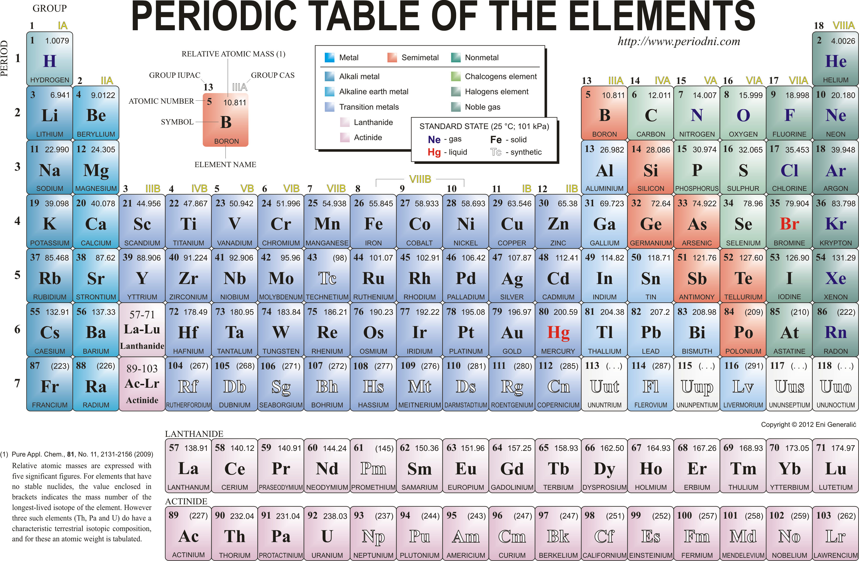

B. Two categories of elements
1. Main Group elements or Representative Elements
a. Groups 1 & 2 and 13 – 18

2. Transition Elements
b. Groups 3 – 12

C. Characteristics of the groups of elements
1. Group1: Alkali metals ns¹
a. most reactive group of metals
b. not found as free elements in nature
c. combine vigorously with non-metals
d. reacts strongly with water to produce hydrogen gas and
basic (alkaline) aqueous solutions
e. stored in kerosene
f. decreasing melting points
g. Soft, Silvery appearance
h. easy to lose an electron to form a +1 cation

2. Group 2: Alkaline-earth metals ns²
a. second most reactive metals
b. never found free in nature
c. reacts moderately with water and acids to form hydrogen gas and basic (alkaline) solutions
d. harder, denser, stronger than group 1 metals
e. higher melting points than group1 metals

3. Hydrogen and Helium
a. Hydrogen, 1s¹, doesn’t share the same properties as alkali metals, its unique
b. Hydrogen is the most abundant element in the universe
c. Helium, 1s², has a filled energy level
d. Helium is unreactive

4. Group 17: Halogens
a. most reactive non-metals
b. react vigorously with most metals to form salts

5. Group 18: Noble Gases
a. completely filled energy levels
b. mostly unreactive

6. Groups 3-12: Transition Metals
a. d block elements
b. good conductors of electricity
c. High luster
d. Less reactive metals
e. Some exist as free elements such as Ag, Au, Pt

7. p-block elements
a. vary greatly in properties
1. right hand side is all non-metals
2. all 6 metalloids form a diagonal separating metals and non-metals
3. left hand side and on the bottom are p-block metals
b. metals are harder and denser than s block metals but softer and less dense than d block metals
c. mostly brittle solids
d. reactive - not found free in nature

