Name Date

Continental Drift Worksheet

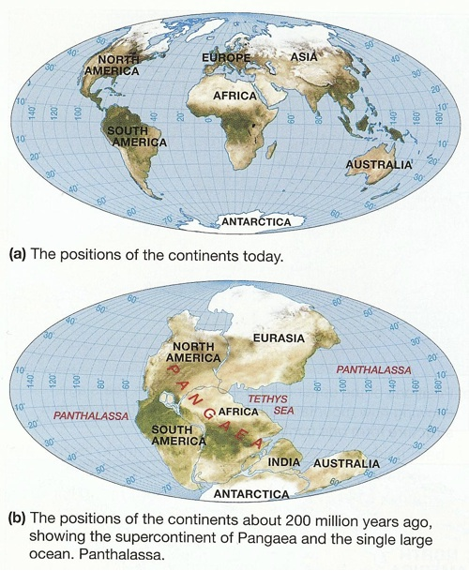

1. When did the supercontinent of Pangaea exist?

2. What was the ocean that surrounded the supercontinent?

3. Why was Wegener’s idea of Pangaea not widely accepted at first?

4. List and explain six pieces of evidence that support continental drift.

5. What had to be taken into account when attempting to fit the continents together to form Pangaea? Explain.

