Chapter 6 Study Guide

Section 1: Introduction to Chemical Bonding
- What is a chemical bond?
- There are three types of chemical bonds that we discussed. Name all three and what they “result from”.
- Be able to determine if a bond is ionic or covalent by using their electronegativity values.
- Determine the difference between a polar covalent bond and a non-polar covalent bond.
- Be able to use the partial positive, δ⁺, and partial negative, δ⁻, symbols on the appropriate atoms in a bond.
- Be able to tell which element has a partial negative or partial positive charge when in a bond.

Section 2: Covalent Bonding and Molecular Compounds
- What is a molecule?
- What type of compounds form molecular compounds?
- What is a chemical formula?
- How do covalent compound’s form?
- True or False. Nature favors chemical bonding so that the atoms have lower potential energy when they are bonded to other atoms and become more stable.
- How does the attractive force and repulsive force affect bonding at each step in the P.E. diagram.

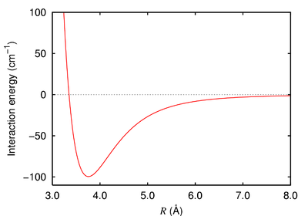

- What do we call the distance between two atoms at the minimum potential energy?
- What is bond energy?
- Define the octet rule.
- What are the exceptions to the octet rule? Why are there exceptions?
- In your own words, describe how to draw a Lewis dot diagram.
- How do you know when a multiple bond is needed?
- How many electrons are shared in the following types of bonds:
- A single covalent bond __________
- A double covalent bond __________
- A triple covalent bond __________
- Put the following bonds in order from strongest to weakest:

Bond | Avg. bond length (pm) | Avg. bond energy (kJ/mol)
H – Cl | 127 | 432
C – N | 147 | 305
C – Br | 194 | 285
N – H | 101 | 386
O – H | 96 | 459

- Why are some molecules or ions represented as resonance structures?

Section 3: Ionic Bonding and Ionic Compounds
- Define Ionic compound.
- Why do we refer to an ionic compounds chemical formula as a formula unit and not a molecule?
- Why do ionic compounds form crystal lattices?
- Define lattice energy?
- Be able to describe the following properties of ionic and covalent bonding:
- Structure
- Strength of bonding
- Formula type
- Melting and boiling point
- Hardness
- Does it dissolve in water?
- Does it conduct electricity?
- What is a polyatomic ion?
- What is different about the Lewis dot structure for a molecule vs. a polyatomic ion?

Section 4: Metallic Bonding
- How is metallic bonding different from ionic or molecular compounds?
- Define metallic bonding.
- What do we mean by “sea of electrons”?
- What are some of the properties of metals?
- How do we determine metallic strength?

Section 5: Molecular Geometry

- Know how to predict the geometry of molecules
- Be able to determine bond angles (look at the bottom of your periodic tables)
- What are the three intermolecular forces?
- Which force acts on non-polar molecules?
- Which three elements combined with hydrogen to produces hydrogen bonding?
- What is a dipole?

