Name Date

Earth Structure Worksheet

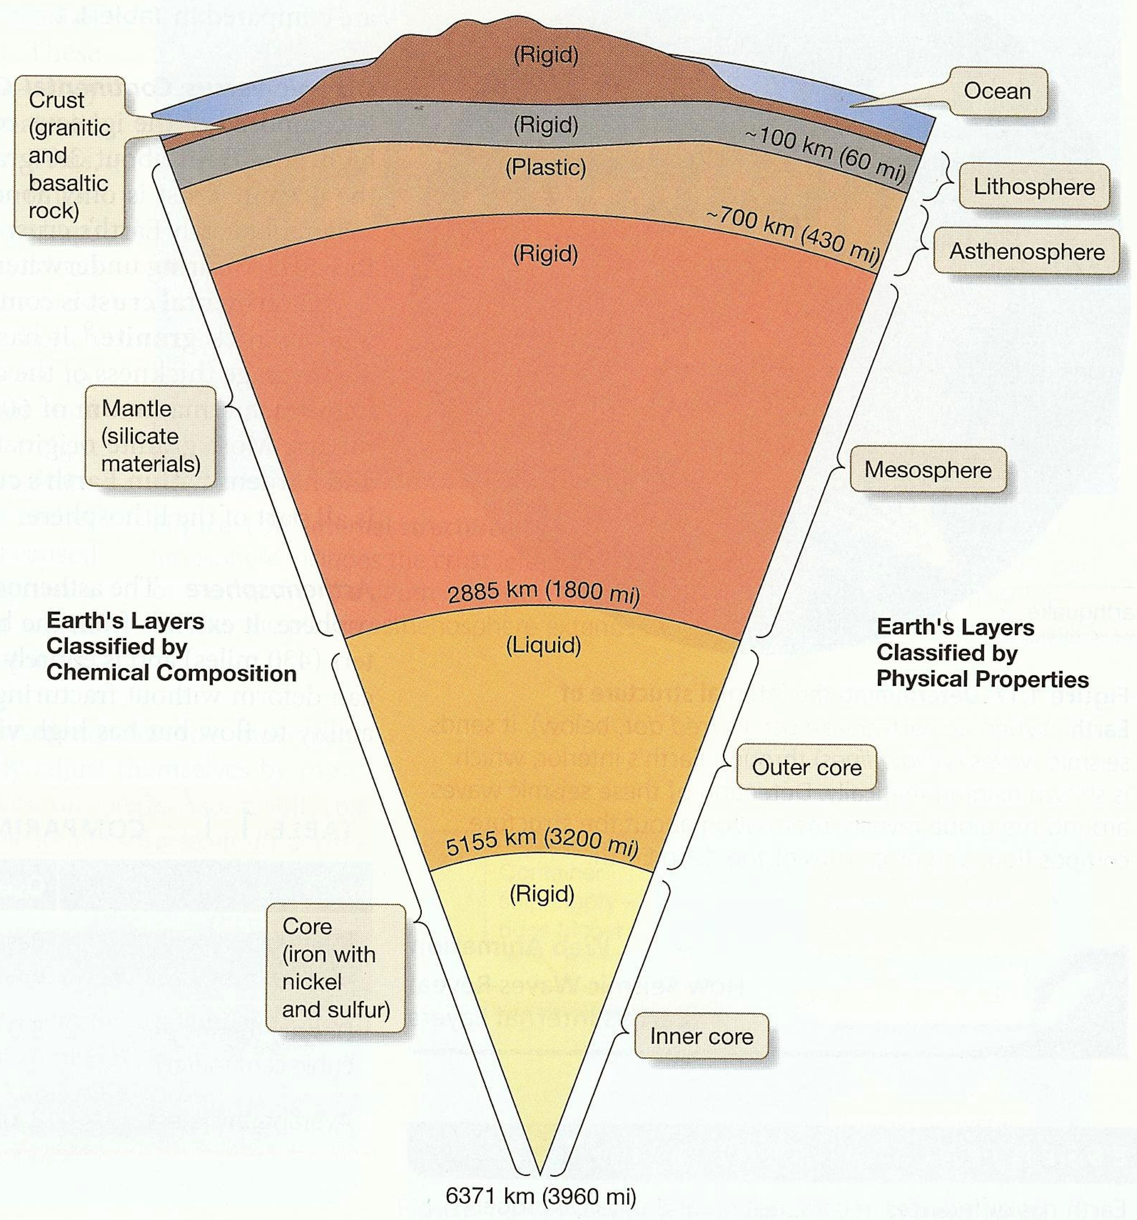

1. What are the categories when Earth is divided according to its chemical composition?

2. Describe the chemical composition categories.

3. What are the categories when Earth is divided according to its physical properties?

4. Describe the physical property categories.

5. What is the main difference between the inner and outer core?

6. Why is the core divided into two separate categories when divided for physical properties, but not when dividing for chemical composition?

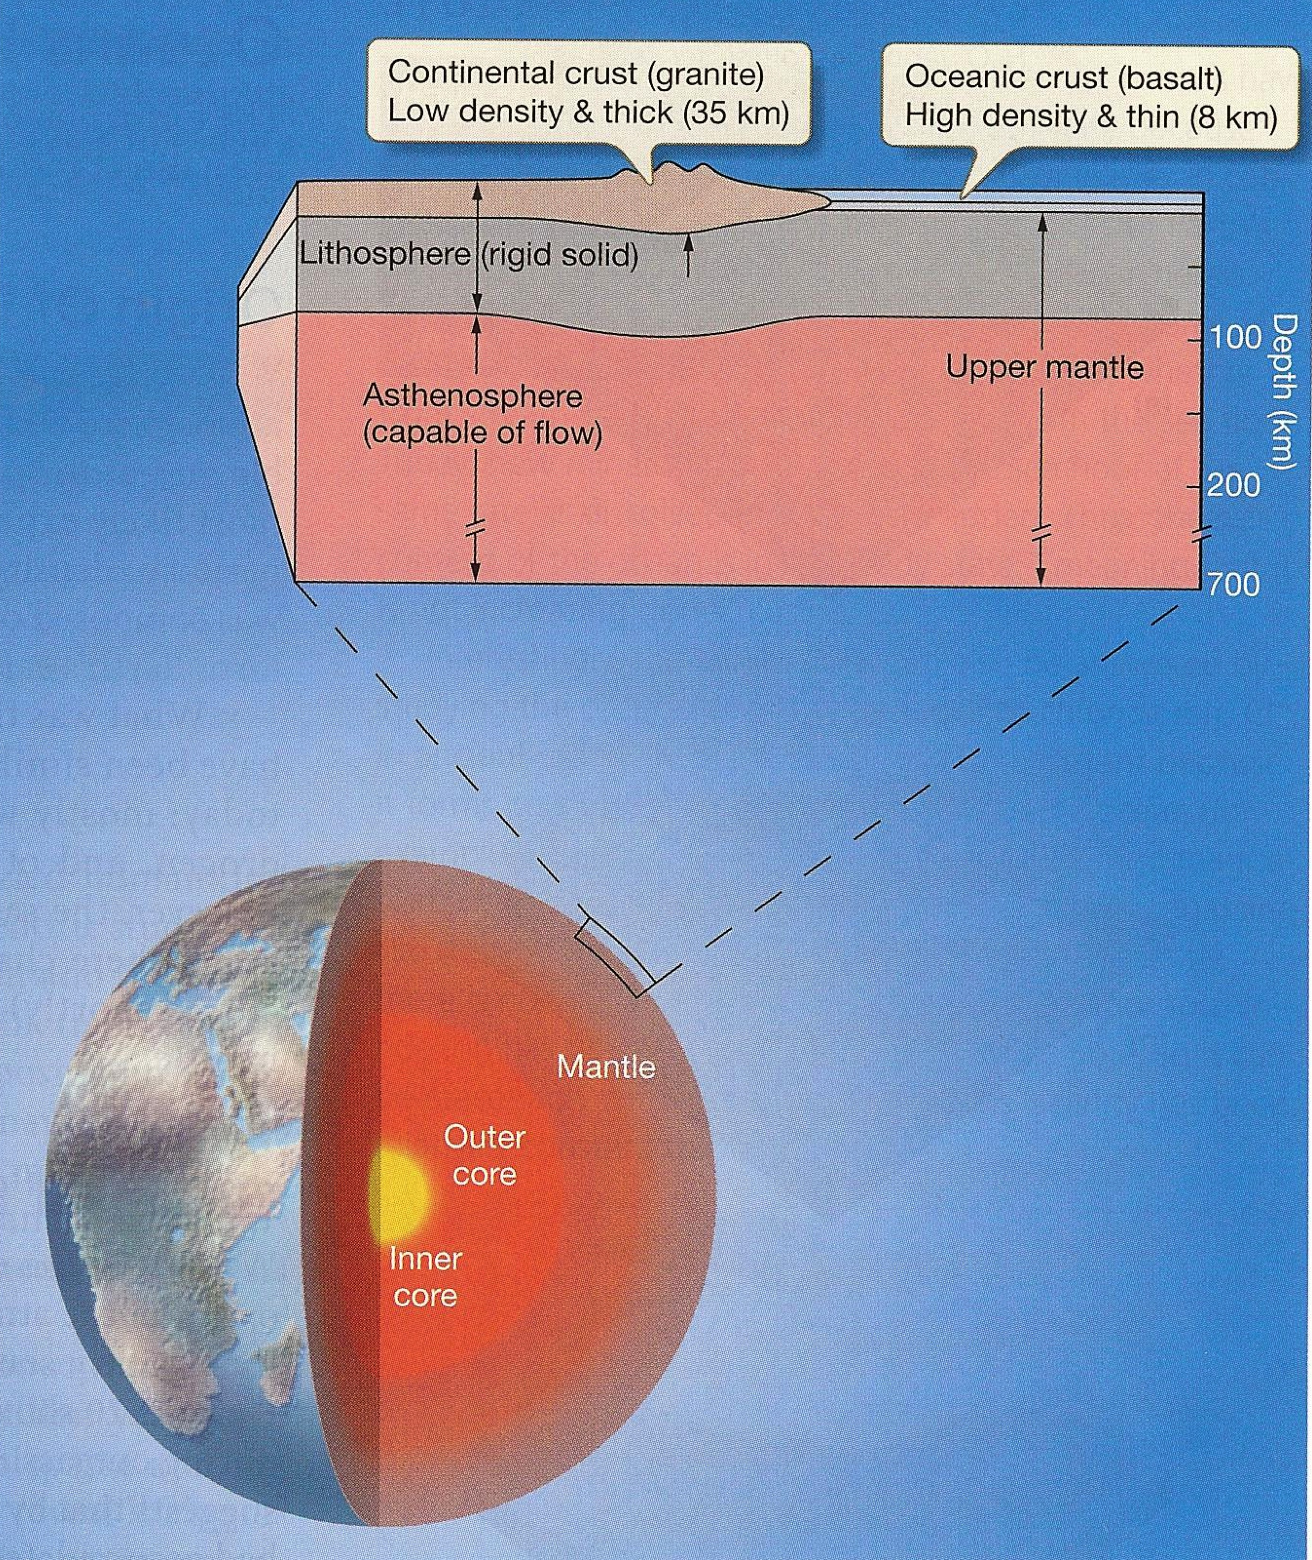

7. Compare the oceanic crust to the continental crust.

8. What is the difference between basalt and granite?

