Name Date

Continental Drift Worksheet

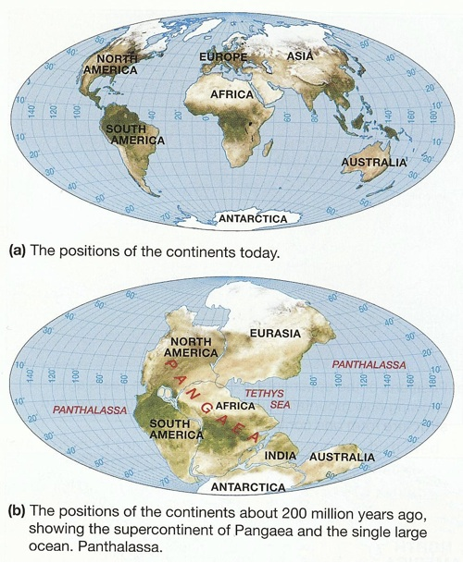

1. When did the supercontinent of Pangaea exist?

The supercontinent Pangaea existed 200 million years ago.

2. What was the ocean that surrounded the supercontinent?

The ocean that surrounded Pangaea was Panthalassa.

3. Why was Wegener’s idea of Pangaea not widely accepted at first?

Wegener’s idea of Pangaea was not widely accepted because many scientists found his ideas too fantastic and contrary to the laws of physics. Wegener’s drift hypothesis was built on the idea that the continents plowed through the ocean basins to reach their present day positions and that the leading edges of the continents deformed into mountain ridges because of the drag imposed by ocean rocks. Further, the driving mechanism he proposed was a combination of the gravitational attraction of Earth’s equatorial bulge and tidal forces from the Sun and Moon.
4. List and explain six pieces of evidence that support continental drift.

Evidence that supports continental drift is:
- Shapes of matching shorelines on different continents
- Rock sequences, types of rocks, age of rocks, and structural styles along coastline edges
- Mountain chains that start on one continent and continue on another
- Glacial deposits in the tropical areas, must have been close to the poles
- Glacier movement leaving grooves on different continents
- Fossil evidence found on different landmasses that could not have crossed the vast oceans presently separating the continents.

5. What had to be taken into account when attempting to fit the continents together to form Pangaea? Explain.

